Lab Exercise 6.1
Managing Jenkins Freestyle Jobs

Objective: To manage Jenkins job by creating, renaming, and deleting freestyle job, facilitating streamlined job configuration and maintenance within the Jenkins environment

Tools required: Jenkins

Prerequisites: None

Steps to be followed:
- Create a new Freestyle Job
- Rename and delete the FreeStyle Job

Step 1: Create a new Freestyle Job

- Open the browser, go to the Jenkins Dashboard by typing localhost:8080 in your browser, provide the credentials, and click the Sign in button


Note: The credentials for accessing Jenkins in the lab are Username: admin and Password: admin.

Output:
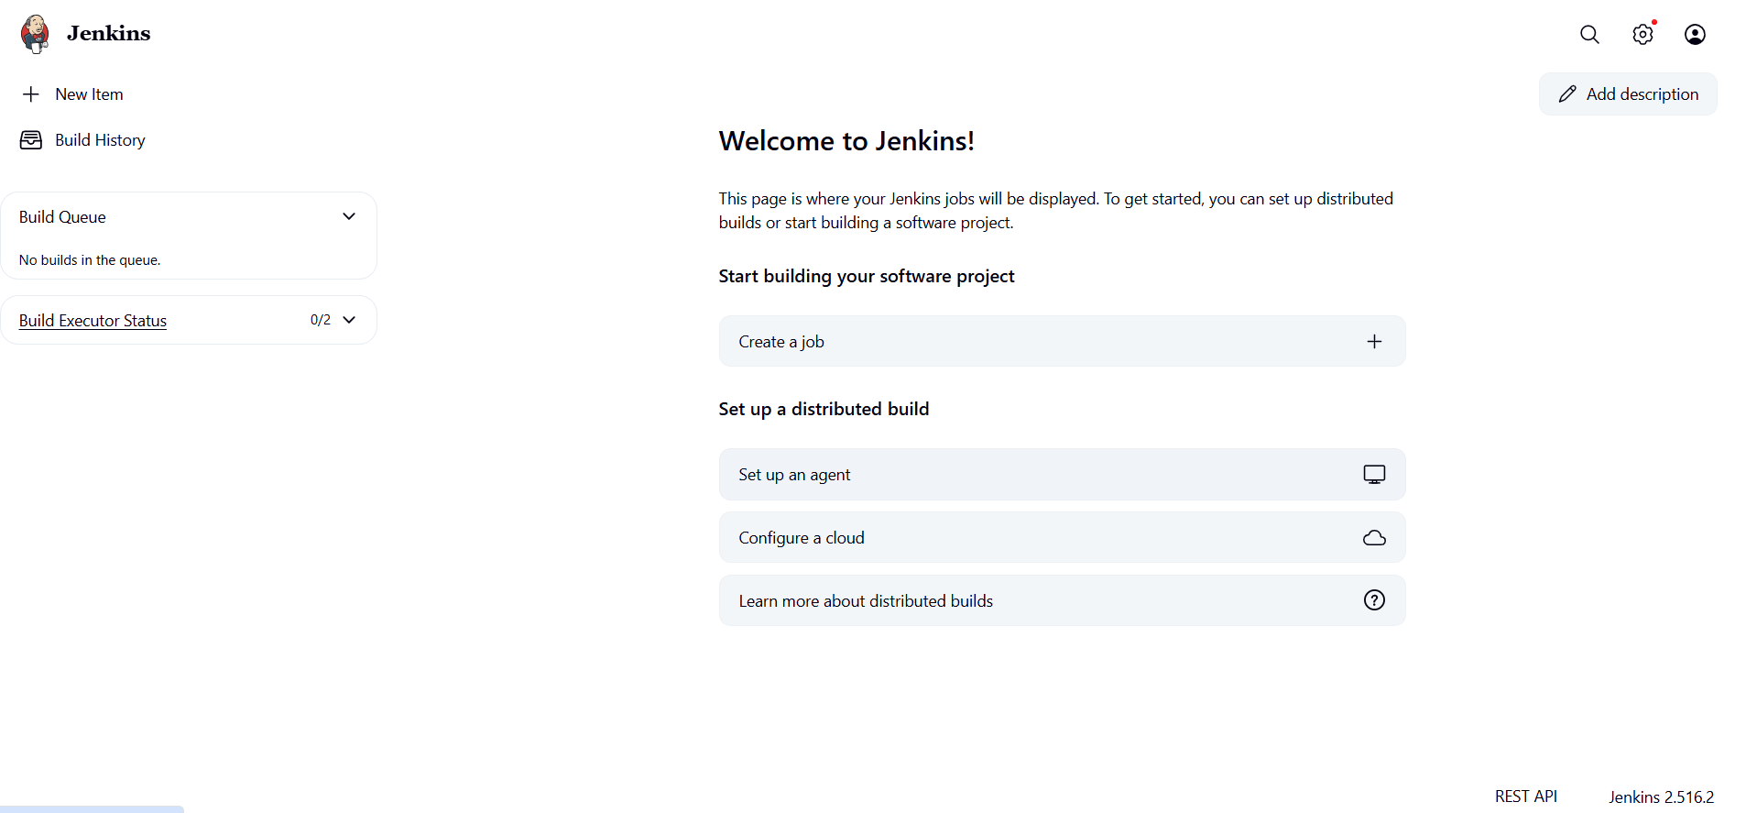

- Click on New Item in the Jenkins Dashboard

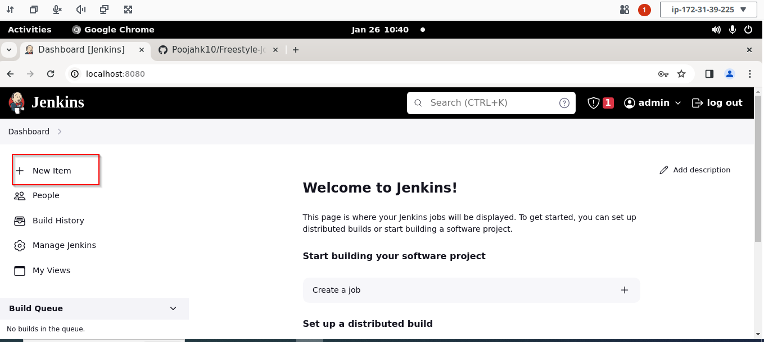

- Enter a name for your project, select Freestyle project as the build job type, and click
on OK
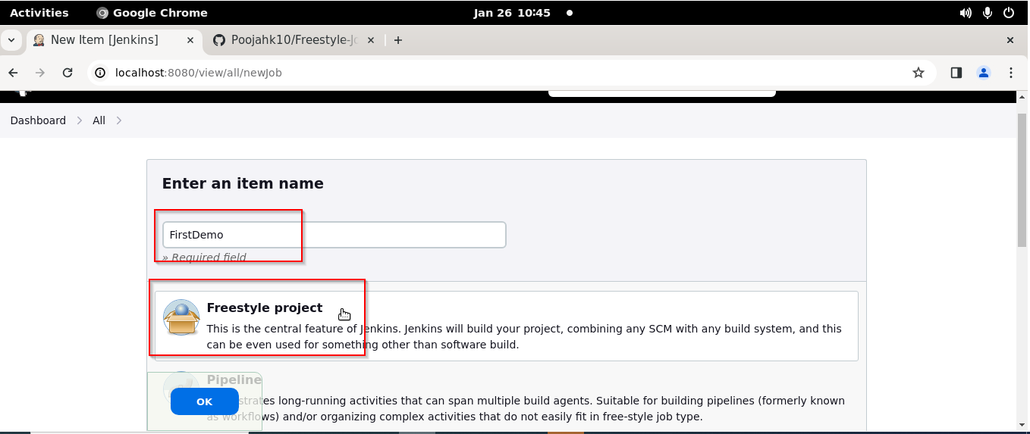

- Click on Save

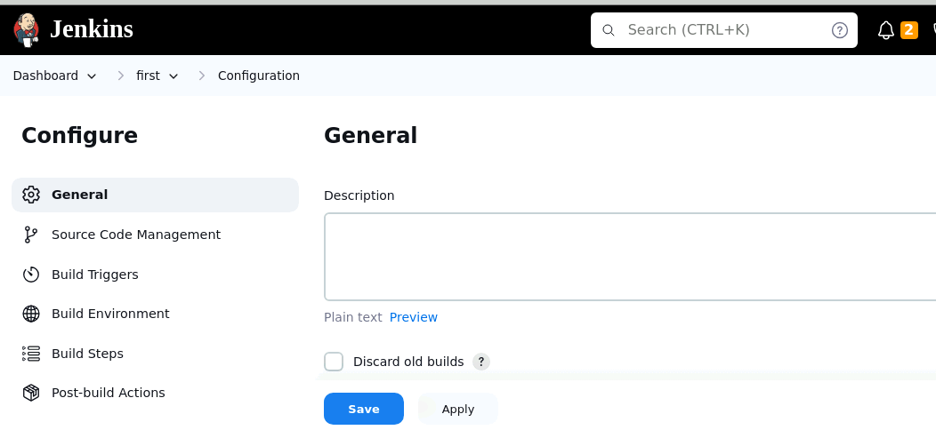

Output:
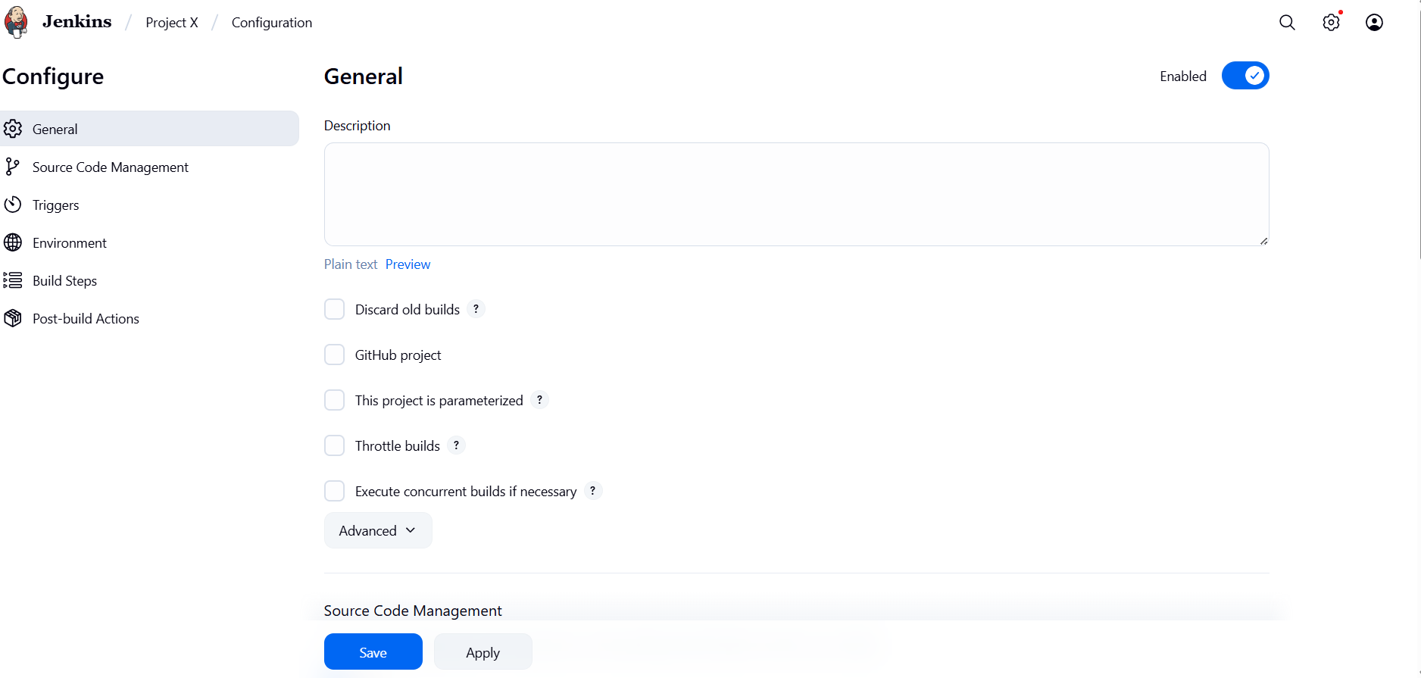
Step 2: Rename and delete the Freestyle Job

- Click on the name of the project that you have created as shown in the screenshot below:

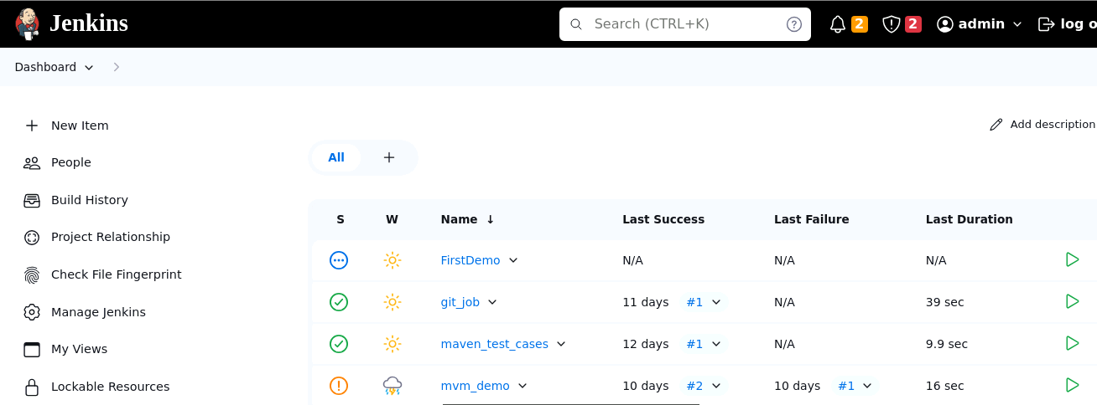

- Click on the Rename button to rename the project

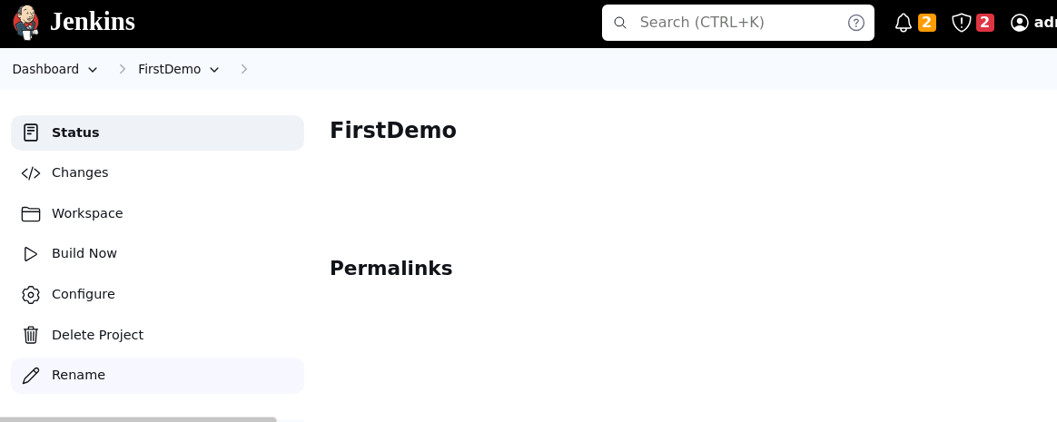

- Enter a desired name to the project and click on Rename

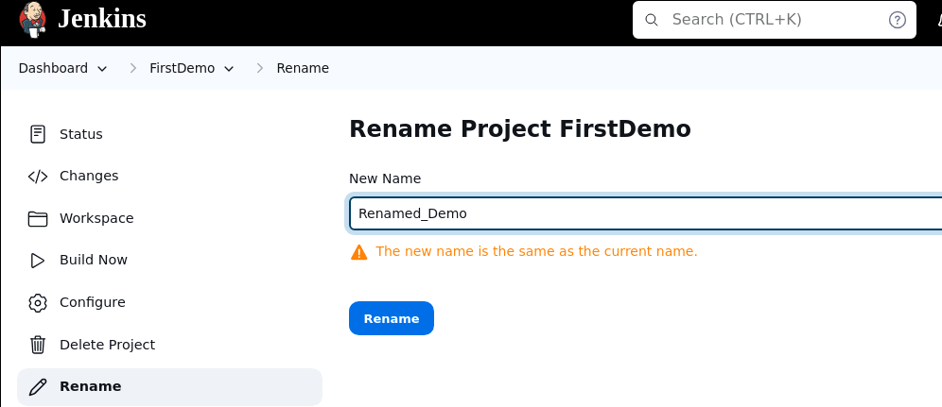

Output:
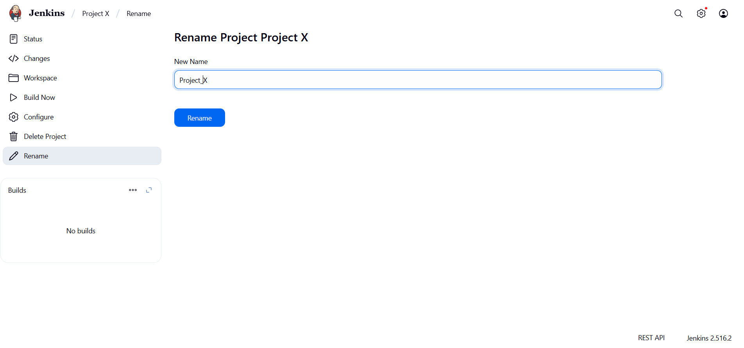

- Click on the renamed project and then click on Delete Project to delete the project

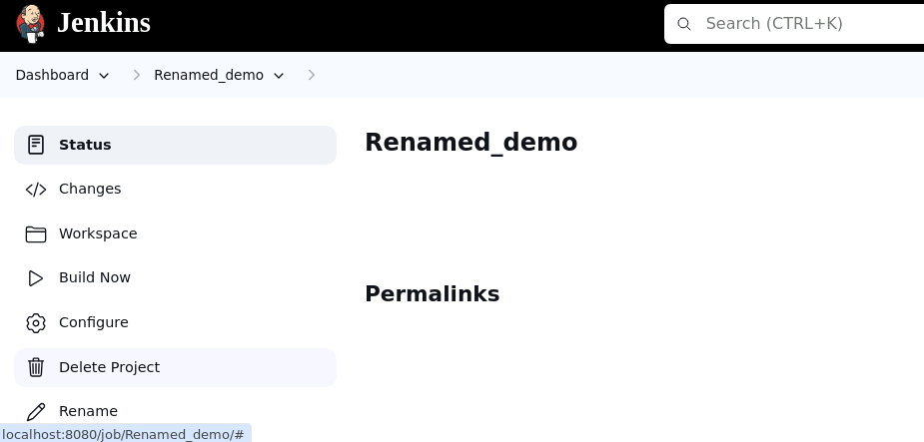

Output:
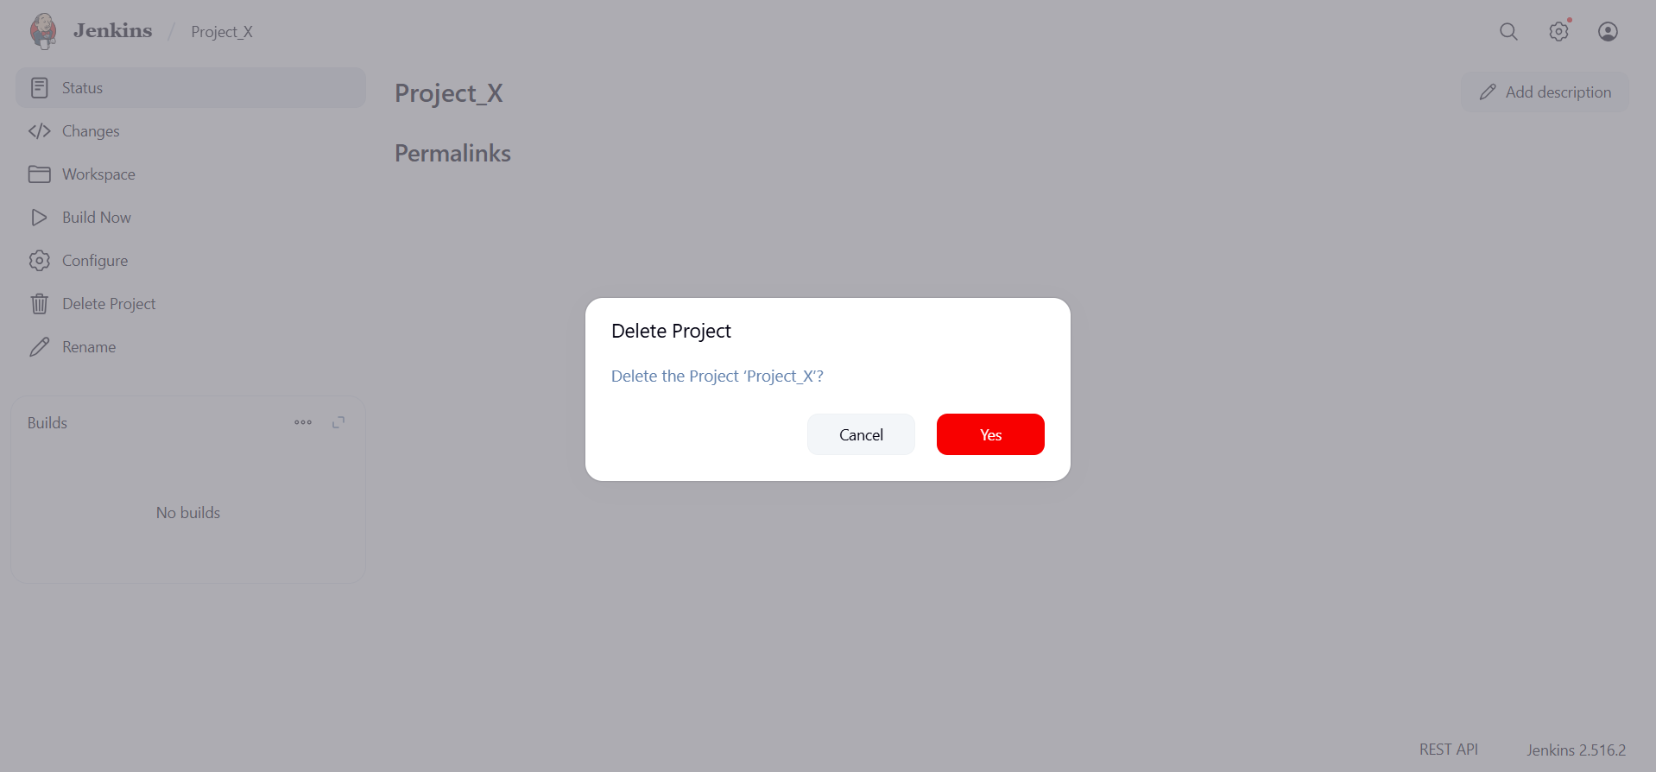
By following these steps, you have successfully managed Jenkins jobs by creating, renaming, and deleting Freestyle Job, streamlining your project workflows within the Jenkins environment.

